**Python Assignment**

1. Plot a line graph for the following values x = [1, 2, 3] and y = [2, 4, 1] and print the respective x, y labels and title named as “line graph” and take a screen shot of the graph.
2. Create a multi-line graph for the following values x1 = [1, 2, 3 ] and y1 = [2, 4, 1] and plot the graph and mark label as “line 1 “ with green color and another set of values x2 = [1, 2, 3] and y2 = [4, 1, 3] and plot the graph and mark label as “line 2” with red color and print the respective x, y labels and title named as “two lines on the graph” use grid in the graph and grid color is black , add style as “classic” and take a screen shot of the graph.
3. Create a bar graph for the movies data number of movies released in the year as x = [2016, 2017, 2018] and year as y = [1252, 1632, 1692] with colors red and blue and print the respective x, y labels and title named as “movies bar graph”.
4. For the table mentioned below,

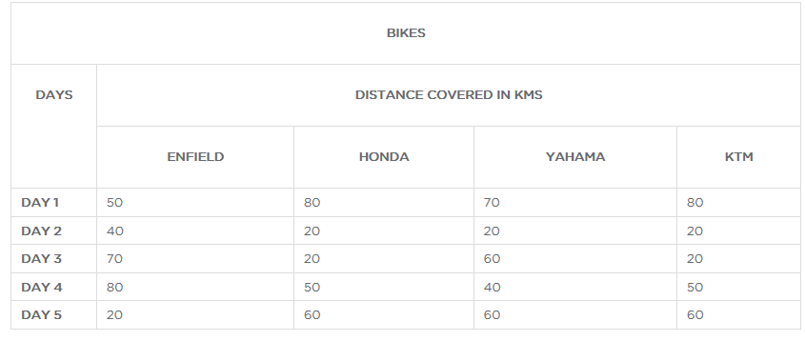

Plot a Pie graph with following values days = [1, 2, 3, 4, 5] and bike names as activities for example Enfield = [50, 40, 70, 80, 20] Honda = [80,20,20,50,60] Yahama = [70,20,60,40,60] KTM = [80,20,20,50,60] and with colors as [‘r’, ‘y’, ‘g’,’b’] and legend as “list of bikes details” and title as “pie plot” and take a screen shot of the graph.

1. Use the same tabular data and create a scatter plot days as x values [1,2,3,4,5] and bike details as y1,y2,y3,y4,y5 namely label as ‘Enfield’,’Honda’,’Yahama’ and ‘KTM’ and x, y labels as ‘days’ and ‘distance’ ,use marker as “ *” and take a screen shot of the graph.
2. Plot a histogram

days =[50 ,80,70,80,40,20,20,20,70,20,60,20,80,50,40,50,20,60,60,60]

bins = [0,10,20,40,50,60,70,80,90,100]

Print the x, y labels as “distance” and “km count” and take a screen shot of the graph.